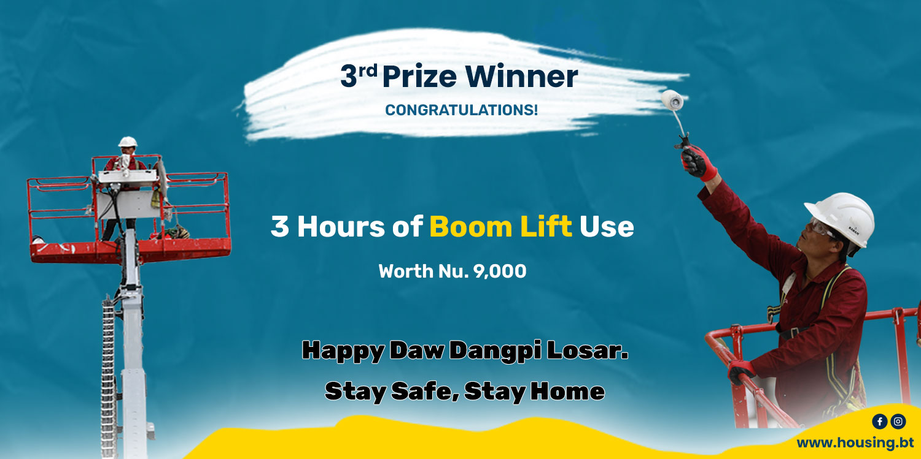
Terms and Condition of Giveaway Prize Claim:
- To claim the prize call us at 17730001 and email us at housing.bt@gmail.com or for clarification.
- The applicant must be the user. Those registering on behalf of user are encouraged to provide user details.
- A participant can apply only once. No user can claim more than one prize.
- The prize must be claimed 30 days from the date of winning announcement made.
- The boom lift use Giveaways are for use in Thimphu only.
- The use of boom lift is subject to usage feasibility. If not feasible it will be transferred to alternative winner.
- The giveaway is non-transferrable. No substitution of prize or transfer/assignment of prize to others or request for the cash equivalent by winners is permitted.
- The Giveaway boom lift use hours are inclusive of marching time.
- The Giveaway does not include supply of manpower for cleaning and maintenance work. Only operator, fuel and dry boom lift use are included in the Giveaway.
- Supply of manpower and consumables requirement is on chargeable basis. User can deploy your own team and supplies. Any additional boom lift hour usage is on chargeable basis.
- The Giveaway coupon once used for the purpose is no longer valid even if the Giveaway boom lift hours are under-utilized.
- The winners can use boom lift only on Tuesdays, Wednesday and Thursdays or as and when the boom lift is remaining idle. The Giveaway boom lift hours use is valid 30 days from the date of announcement of winners.
- Acceptance of prize constitutes permission for [housing.bt] to use winner's name, likeness, and entry for purposes of advertising and trade without further compensation.
- If the Winner does not fulfill or accept the above terms and condition, the Giveaway shall be revoked and offered to alternate winner.

